Congregation Bonai Shalom
Boulder, CO


Project Details
Description: .............................................. 12,000 sf synagogue
Owner:...........................................Congregation Bonai Shalom
Architect:....................................................................... Stantec
General Contractor: ....................................Swinerton Builders
Budget: ......................................................................... $16MM
Completion:....................................................Anticipated 2027

Project Description
Congregation Bonai Shalom is a synagogue and Boulder that is designing and constructing a new 12,000 sf facility across the street from the existing building. The new building will contain a sanctuary, social hall, administrative suite, community gathering space and an education wing with five classrooms. The design team is finishing the Construction Documents and finalizing Site Plan approvals in advance of submission for Tech Docs review. Construction is anticipated to commence in Q3 2026 with building delivery in Q3 2027. The project is 100% funded by donors through a capital campaign.

Scope of Services
SII was engaged during the preliminary planning phase and has been involved to date in every aspect of the campus’s design, entitlements and permitting. Eric Shafran serves as Project Executive and Cord Green is the Project Manager. Engaged in a full- scope capacity, SII is responsible for:
- Negotiating and managing phased contracts with Stantec for design and Swinerton Builders for preconstruction services, including ongoing oversight of design, preconstruction, and permitting.
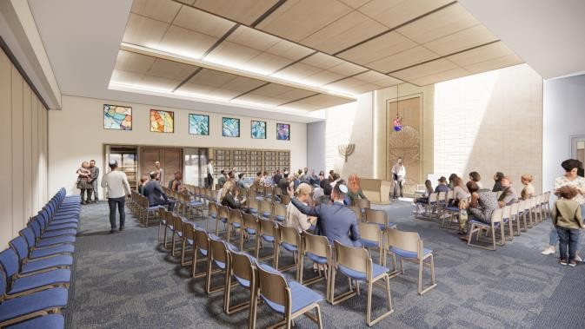
- Developing and managing phased budgets, including daily oversight of invoice processing, exposure tracking, contingency administration, cash flow reforecasting, and lender relationship management.
- Leading extensive value engineering exercises with Swinerton and Stantec at each project phase.
- Coordinating all FF&E selection, procurement, assembly, and installation from multiple primary and secondary vendors.
- Engaging utilities and directing the delivery of new services.
- Soliciting, negotiating, and finalizing additional professional service contracts—including survey, geotechnical investigation, construction and material testing, audio-visual and low-voltage systems, signage design, fabrication, and installation—and managing delivery of all associated services and deliverables.
- Maintaining overall responsibility for project delivery, including quality control, schedule management, resolution of vendor issues, building handoff, and startup coordination with synagogue staff.
- Ongoing communication with the various synagogue committees, including their Architecture and Design Committee, New Building Leadership Team, Executive Committee of the Board of Trustees, Capital Campaign Committee, and Green Team.

